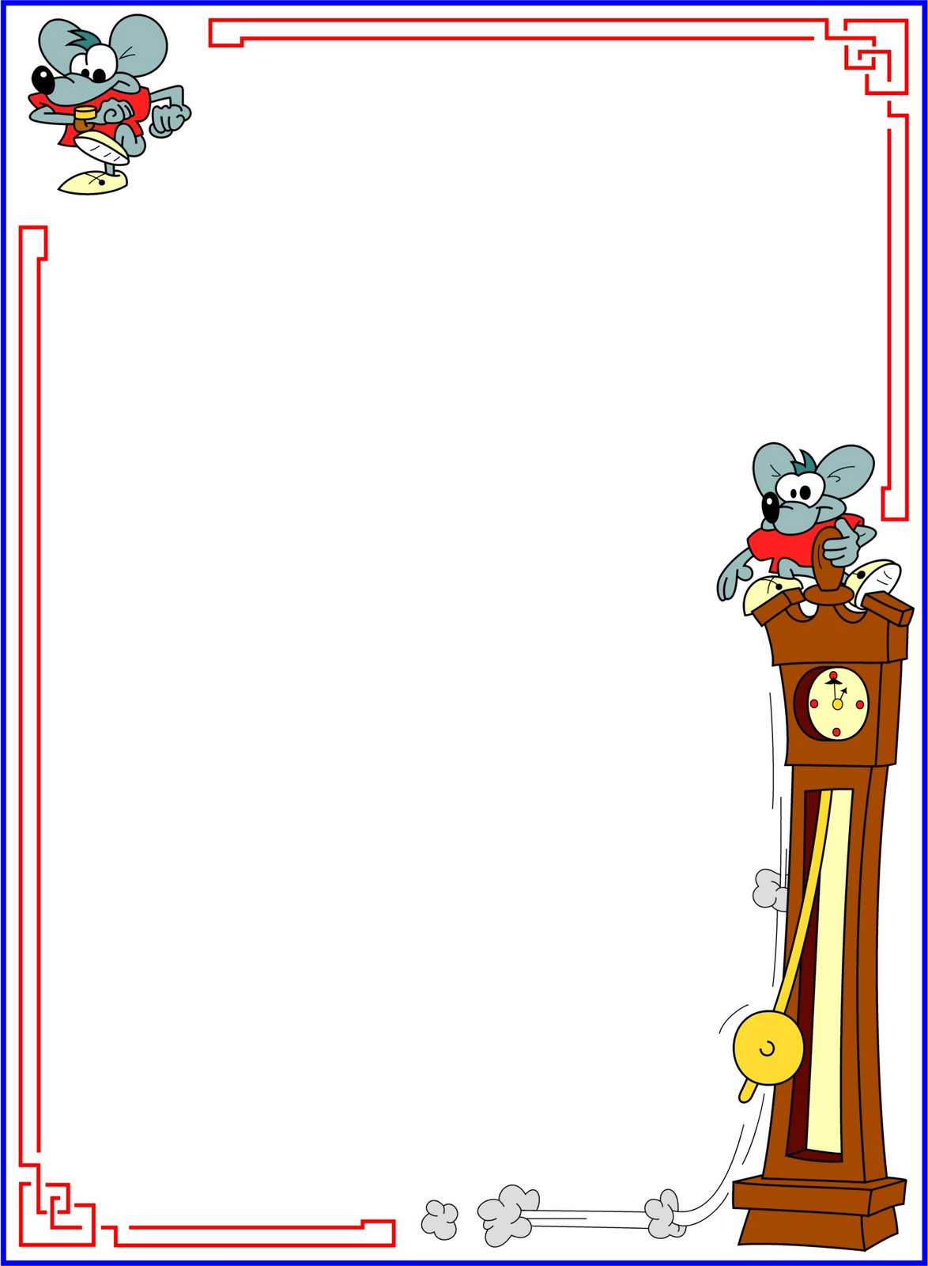
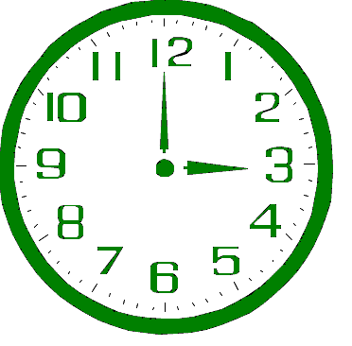
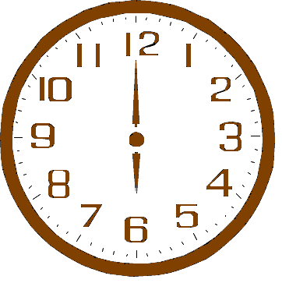
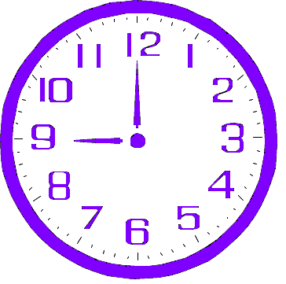
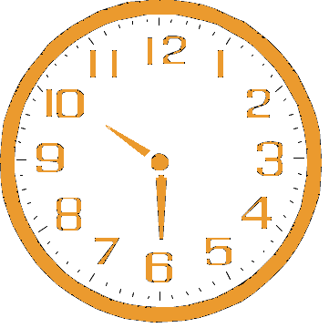
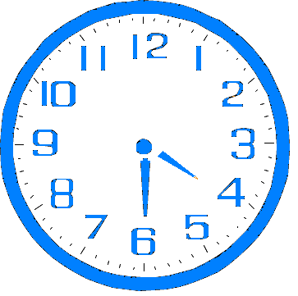
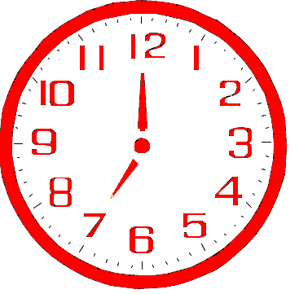
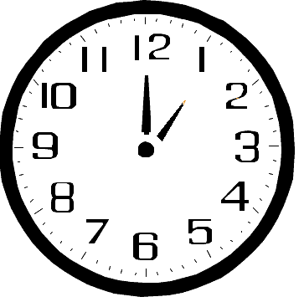
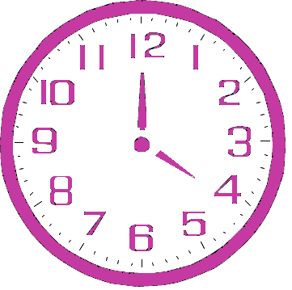
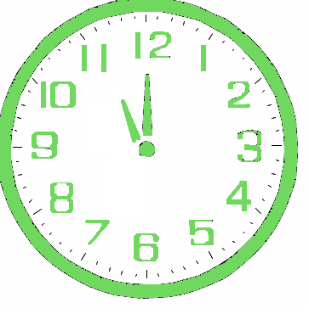
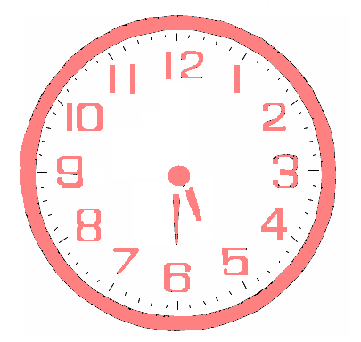
What time is it?

IT IS SEVEN O’CLOCK.
IT IS FOUR O’CLOCK.
IT IS HALF PAST TEN.
IT IS ELEVEN O’CLOCK.
IT IS THREE O’CLOCK.
IT IS SIX O’CLOCK.
IT IS HALF PAST FIVE.
IT IS HALF PAST FOUR.
IT IS ONE O’CLOCK.
IT IS NINE O’CLOCK.

